UBI Flood
Introduction: 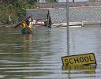
Flooding in cities has become more frequent due to increased population, rapid urbanization and unplanned development. Flood management requires an understanding of causes and forecasting of floods to reduce the impacts of floods. Sensor Networks are currently being considered for critical monitoring. For example, in this project our main purpose is to provide continuous access to real-time water level integration with multiple sensors and model predictions/forecasts.
The main functionality of this system includes
- Real time monitoring of water level using water level sensor
- Send SMS to registered users if water level exceeds the defined level. System will get the possible flooding zone from the pre-created scenarios (either from GIS, flood models or so ...)
- Based on the flooding zone, system triggers the public siren system and sends warning information to public display system
- System has the capability to switch/power off the device, if water level exceeds critical level
- System will get reply from SMS recipients, confirmation of flooding in that area.

Web based SDOA platform is used in this paper to collect, manage and disseminate data, on flood forecast. The system includes different layers such as infrastructure layer, presentation layer and integration layer. The layers includes sensor modules, sensors network control box with presentation layer functionalities to effect access, distribution and update of spatially attributed data via basic web services for devices. Then, the system takes advantage of mapping and web-services technology to publish and compose data in the system. In our application, it allows dissemination of alerts based on the underlying forecast technology on information in the form of text; maps (E.g. spatially distributed rainfall map and flood inundation map dynamically through the Internet and WAP services.

General work flow diagram:

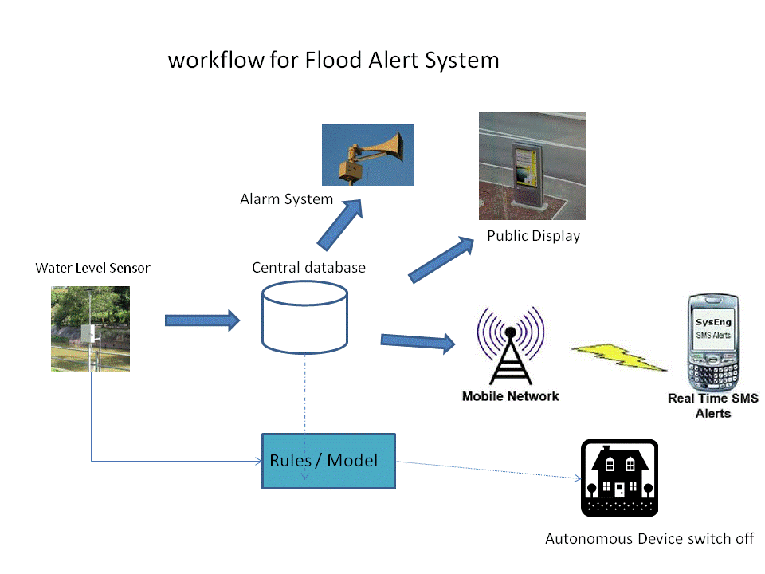
General Approach and main contribution

In the general early warning systems, system will be using radar data, rain gauge data in the model and gives the flood prediction results. But this is time consuming and need manual support. But in our proposed system all those models will be pre-created based on some scenarios. Those results will be used based on the scenario. So the system will be fast and reliable.

Work flow of Early warning system

Warning System
Flood Model
Rain gauge
Radar

The above defined figure is the general work flow if early warning system. In this, system will use radar data and rain gauge data in rainfall model to predict the result. Based on the result system will send the warning to public. This type of system is not reliable and slow. General flood models will take more run time even some model will take 15 hours to produce result and there may be manual intervention needed. Models are only predicted based on previous year’s data and other factors. Many times the result will be not reliable. So, alert system with sensor will be more reliable and proven.
Alarm System
Pre-created scenario
Sensor

Sensor will provide real time water level data so it is more reliable than forecast data. The flood area / zone will be calculated from the pre-created scenario. It is offline so the producing results will be much faster than the online system. In the above given workflow, as a input from sensor data, pre created scenarios will give more reliable flood area / zone.
Classical Process
Flood model / GIS model

Sensor value Alert device
Simplified Process

Pre-created scenario’s

System overall Flowchart

Check for flood zone from pre-created scenarios
Check for flood zone from pre-created scenarios
Check for flood zone from pre-created scenarios
Database
Water Level Sensor

If water level exceeds alert level 2
If water level exceeds alert level 3
If water level exceeds alert level 1

YES
YES
YES

SMS to Experts
Expert List
Expert List
Area
Area
Flood Zone
Possible Flood Zone
Flood Zone
Possible Flood Zone
Flood Zone
Possible Flood Zone
Area
SMS to Experts

Expert List

Something could happen, you are in risk
Something could happen, Expected flood in ... (time)
SMS to Experts
You will be flooded – Risk High

You will be flooded
You are in danger, go to safe area

: SMS Message

: Mobile Network

Features:
- Water level data taken at specific time period will be enter to database
- There can be 3 alert water level like minimum, mean and maximum or so... for example 10m below the drain height will be minimum (alert water level 1), 5m below the drain height will be Mean (alert water level 2), 2m below the drain height will be minimum (alert water level 3) (see fig1)
- If water level exceeds this alter level, database will trigger the suitable pre-created scenarios from model / GIS to find
  - Flood area or location
  - Flood zone
  - Possible flood zone
Refer to fig2
- System will check the experts / officials in that area and send SMS with sophisticated graphic representation & messages
- System will send different SMS message to public in flood zone and possible flood zone.
- System should be able to send photo, map, image, text messages based on the device.

Fig1
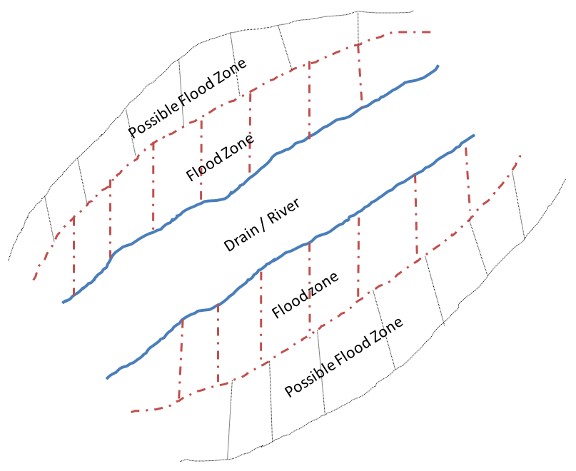
Fig 2
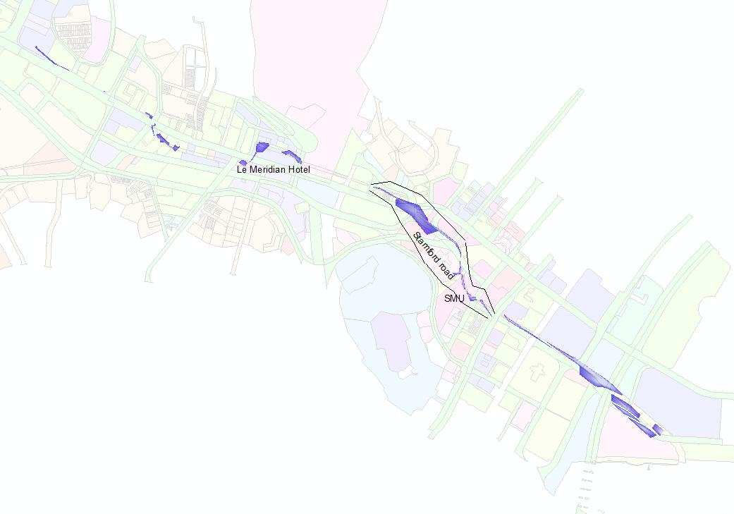
Flood Zone
Area
Possible Flood Zone
Fig3: Flood map
Communicate to people:
System will send sms alert on the 3 cases
- SMS / MMS alert will be sends to all government officials / experts in the flooded admin zone based on their phone model. Those officials / experts information will be stored in the database
- SMS / MMS alert will be sends to registered public. Public can register to get alert on their zone of interest. While registering, they need to provide phone model. This alert is not on location based. For ex. If he register for zone A he will get information only for zone A even though he may not be there while flood in that zone.
- SMS / MMS alert to registered users. He doesn’t want to register for a particular zone. This alert is location based service. That is, if he register with the system, he will get flood alert if he is in the flooded zone.

MMS
SMS
Admin Zone
Expert DB

MMS
SMS
Zone
DB
Website
Public

Location
MMS
SMS

Software architecture Network
Website
DB
Display
SMS
Rules

WCOMP
Message
Zone
Logical Part

Sensor
Siren

Smart home

